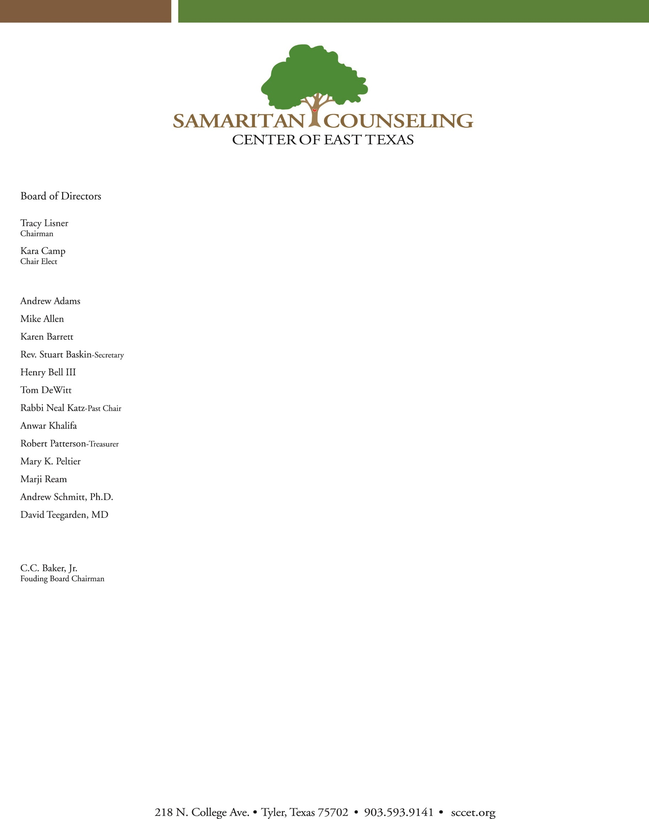

Board of Directors Meeting

Tuesday, November 7th, 2016

AGENDA

1. Call to order, Tracy Lisner, President
2. Prayer
3. Review and Approval of October Meeting Minutes, Stuart Baskin, Secretary
4. Financial Reports, Robert Patterson, Treasurer
5. Review and Approval of 2016 990 as prepared by Barrett & Thomas, P.C., Mr. Patterson
6. Executive Director Report, Chris Taylor, E.D.
   1. Update on onboarding of new E.D.
   2. Survey Results
   3. Strategic Planning and Operations
      1. People
      2. Service
      3. Quality
      4. Growth
      5. Finance
7. Development Report, Henry Bell III, Development Chair
8. Building Committee Report, Mr. Lisner
9. Other Business
10. Adjourn